Overall
- Integration with LMS: Where will the videos show up?
- Masterclass – Free video content + free exercises…
- If people do an activity twice in a day, where will it get logged?
- How will we show activities during and after the video-based learning?
- How will we scale the app pages when there are more programs in the future?
- Need to talk about pop up notifications
- Discussion forums??

Onboarding
- Onboarding 1
  - <Placeholder for logo>
  - Need to see animation
- Onboarding 1-1 (“Welcome back”- sign in page)
  - Make illustration more inclusive to show diversity (genders, ages)
- Onboarding 1-2 (“welcome to your sanctuary” – get started page)
  - Illustration to signify movement, journey, reflection (not seated meditation, and not religious for sure)…. Some initial images for a directional emotion, but needs more research…
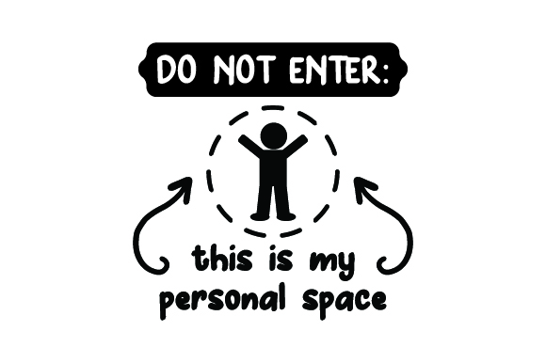 , 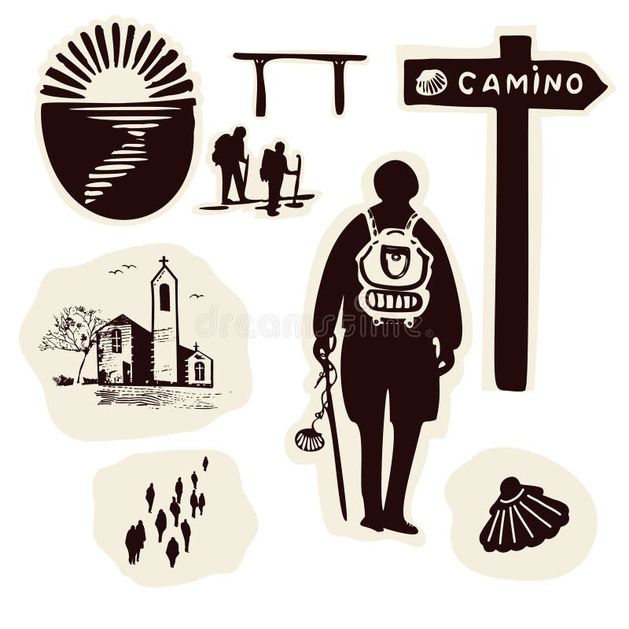 , 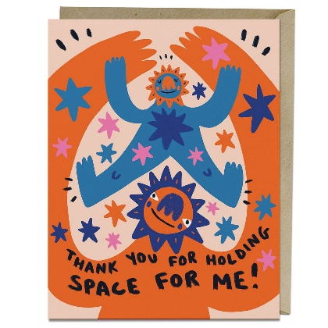

  - “A space to breathe observe, reflect, and grow at your own pace.”
- Onboarding 1-3 (“Find your center”)
  - Placeholder - Need to think how this page will flow
- Onboarding 1-4 (“check in with yourself”)
  - Placeholder - Need to think how this page will flow

Course flow
- Dashboard (“Welcome to atmospheric presence”)
  - 4 boxes should represent the 4 segments of the video based courses
  - “Welcome to Atmospheric Presence” “Welcome to Behavioural Signal Intelligence”
  - “Begin a mindful journey to harmonize your somatic sensations with emotional clarity.” “Begin your self-reflection journey by harmonizing your somatic sensations with emotional clarity.”
  - “Identify your current mental field” “Identify your current emotional energy”
  - “Body awareness” - TBD
  - “Map physical sensations in real-time” “Map physical and physiological sensations in real-time” OR “Map your current somatic sensations”
  - “Pattern awareness” - TBD
  - “Connect behaviors to biological cues” “Connect behaviors to nervous system cues”
  - “Insights” “Reflect and Act”
  - “Deep psychosomatic data analysis” “Insights into psychosomatic synthesis”
  - “Start assessment” should be based on the video flow
- Dashboard 1 (Awareness states)
  - Needs to break down into following different pages
    - Instead of the current grids, I need the 6 grids as below with a title like “Let’s check your daily activation”
Excitement and enthusiasm | Alert and nervous | Irritation and rage
Calm & steady | Resilient & contesting | Stuck & rigid

    - Next page - Once 2 are selected, user should be able to see corresponding Energy orientation + flow state (eg. If someone selects alert & nervous, they should be able to see 1) Energy Orientation is Activation with some text explanation 2) Flow stability is waver with some text explanation)
    - Next 6 grids appear again with the title “Let’s check for expansion”
Joy & abundance | Surprise & embrace | Spiralling & enveloped
Compassion & acceptance | Protection & resistance | Repress & conflicted
    - Same as before, once 2 are selected, user should be able to see corresponding Energy orientation + flow state (eg. If someone selects protection & resistance, they should be able to see 1) Energy Orientation is Embodiment with some text explanation 2) Flow stability is waver with some text explanation)
    - Next page – 2 high points & low points through value systems.
From 7 options/boxes (Work, Relationships, Family, Finances, Personal Development, Health, Previous Stress), select 2 sets of options (2 causes of high points & 2 causes of low points)
    - Next page – for each of the 4 selections in the previous bullet, select corresponding root cause. Choose between 4 options [1) learned emotional strategy 2) recurring environmental stressor 3) protective belief or meaning 4) Unmet need]
    - Summary section – repeat all the steps again
- Dashboard 2 (Somatic states):
    - General instructions:
      - Need to break this down into multiple pages
      - Click on 1 body part, select between 3 – 5 options (text + symbol)
      - For the selection, pop up corresponding awareness check tests, with 3-5 outputs (text based)
      - From the awareness check test, show corresponding activities that the user should do..
    - Head
      - Select between 3 signs/texts: Brightness & Clear Focus (✦), Dizzy / Spacey (💫), Heaviness in the Head / Fog (🌫)
      - If ✦ is selected progress to Awareness Test #1 “The 60-Second Cognitive Check” go to “Expand the Window” activity (5 slow diaphragmatic breaths) move to next page
      - If 💫 is selected progress to Awareness Test #2: The CO₂ Indicator go to exercise #1: CO₂ Rebalancing (breath hold training) go to exercise #2: Sensory Anchoring move to next
      - If 🌫 is selected progress to Awareness Test #3: The Flexibility Check go to Exercise #1: Cognitive Diffusion Drill go to exercise #2: Fatigue check
    - Face & throat:
      - Select between 3 signs/texts: relaxed & bright (🌞), subtle tension (⚡), excessive clench (ꟿ)
      - If ⚡or ꟿ is selected Awareness test #1 Clench Detection Drill Exercise #1: Jaw Awareness Reset Awareness test #2: Throat Openness Check Exercise #2: Belly breathing Awareness test #3: Neck release awareness Exercise #3: Shoulder drop
    - Heart:
      - Select between 5 signs/texts: Increasing Pulse — Healthy Activation (◯), The Release — Expansion through the Heart, The Steady Heart — Integration, The Pounding Heart — Waver and Unrest (💓), The Heart Ache – Chaos and ache (✸)
      - If Steady Heart - Integration is selected Move to exercise #1: Baseline Pulse Awareness
      - If Increasing Pulse - Healthy Activation (◯) is selected Move to Activation differentiation test Move to coherence breathing exercise
      - If The Release — Expansion through the Heart is selected Exercise #1: Expansion allowance practice Exercise #2: Sternum & pec stretch
      - If The Pounding Heart — Waver and Unrest (💓) is selected Move to Activation differentiation test Move to Exercise #1: coherence breathing Exercise #2: shoulder & neck stretch
      - If, The Heart Ache (✸) – Chaos and ache is selected Exercise #1: Expansion allowance practice Exercise #2: Sternum & pec stretch
    - Chest:
      - Select between 4 signs/texts: Calm, unrest, spiral, tightness
      - If calm is selected Diaphragmatic baseline check test 360 degree breathing exercise
      - If unrest is selected CO2 check Breath hold exercise
      - If spiral is selected CO2 check Breath hold exercise
      - If tightness is selected chest tightness vulnerability check Exercise #1: light shoulder and arm movements Exercise #2: lie on the bed with the head back Exercise #3: Sternum & pec stretch
    - Stomach:
      - Select between 3 signs/texts: Butterflies, whirlpool, armour
      - If butterflies Exercise: Belly softening
      - If whirlpool or armour abdominal scan test for baseline awareness Exercise #1: belly softening Exercise #2: safety cue Exercise 3: Gut reaction
    - Hands & legs:
      - Select between: Calm, springy, braced, sluggish, contracted, fidgety
      - If calm / springy grounding drill
      - If sluggish freeze check
      - If fidgety fist clench, shoulder drop
      - If braced, contracted #1: fist clench #2: shoulder drop #3: Proprioception grounding
- Dashboard 3 (pattern awareness)
  - “Draw your breath” “Map your breath”
  - Activity experience
    - How does a person draw on an app vs a web?
    - How does the screen keep moving?
    - Time – TBD
  - Need to see how the output will look at the end of the exercise
- Dashboard 4
  - “Reflect & Act” “Reflect”
  - Need to make this into 5 parameters - Emotional state, Somatics, Presence & attention, Action, Pattern
  - Suggest options for visual representation
  - Daily synthesis, weekly trend, suggestive text etc – <Need to update comments>
- Dashboard 5
  - “Reflect & Act” “Act”
  - Representation & rules - <Need to update comments>
- Dashboard 6-11
  - Align with course’s exercises - TBD

